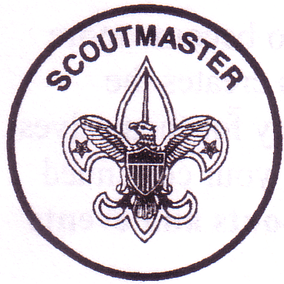 | BSA Troop 188  New Scout Welcome Packet  2017 | 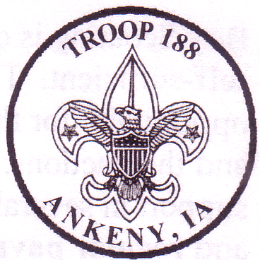

To the Family of a New Boy Scout;
I want to welcome your entire family into this next stage of your son's growth in Scouting. As you will see over the next few months, we are a growing and energetic Troop that enjoys many opportunities for Scouts to camp, learn new skills, participate in community service projects and mature as young men. I have enclosed several items in this packet to aid in the transition of your Scout into Troop 188. Please review these documents and ask any questions that you may have. These items include;
- Boy Scout – Youth Application - if your scout was in a Cub Scout Pack – there is no transfer fee.
However, if your scout is new to Boy Scouts, there is a fee of $24 which is prorated to your start date. Starting in March, fees are $20
- Troop fee - $19 (prorated beginning April-December $26/yr)
$26/yr fee covers (Troop equipment, campsite reservations, dues)
- Troop Code of Conduct - Youth
Please review with your Scout. Scout & parent sign and return to the Troop
- Troop Parental Consent Form
Please till out and return ASAP, as your Scout cannot go on outings without this.
- Adult Volunteer Leader Application - If you were a registered leader for a Cub Scout Pack, there is no transfer fee. $20 for new Adult Leaders beginning in March.
The adult yearly recharter fee is $24 and goes directly to the Council.
- Adult Code of Conduct
This code of conduct is very similar to the one for our Scouts. We are asking that adults review and sign this. We want everyone to be aware and agree to the same high standards in Troop 188.
- Adult Youth Protection
Troop 188 requires any adult leader or parent that will be interacting directly with Scouts or attending campouts/summer camp, or going on any outing, complete the Adult Youth protection program located on the Troop website link. This is an online course.
- Troop 188 Parents Handbook
This booklet is designed for you to find quick answers too many questions you may have. Feel free to talk to the Scoutmaster or any of the Assistant Scoutmasters to answer your questions as well.
- Troop Resource Survey for Adults
Information on this form is used to update our troop roster. We need the contact information that is asked for on this form back as soon as possible, so that we can get communications out to you and your Scout.
- Annual Health and Medical Record Required to attend summer camp!
The BSA requires that all Scouts and registered adults will get a physical every 12 months and use the "BSA Health and Medical Record" form.
- Required gear for troop meetings checklist
Have your Scout put this list of items together in the first couple weeks.
- Personal Camping Gear Checklist
This will be covered by your sons Patrol Leader before his first campout.
- Boy Scout Insignias (Uniform information)
- All of you have been informed and have been given paperwork regarding summer camp. Please go on our website or ask any adult leader if you are in need of any summer camp forms. The following is required for summer camp, deposit/payment for camp, merit badge selections and the BSA medical form (to be handed in closer to our camp date)
.
(OVER)

Boy Scouting is quite a bit different than Cub Scouting. The Scout is required to become more self-sufficient. The Scouts lead meetings with the support of adult leaders. This creates the opportunity for the boys to become more independent and develops responsibility for themselves and their actions. But, we also realize that a Scout is still a boy. He will require your continued support in several areas, which two of the biggest are, Transportation to campouts and events and campout fees.
Weekly Meetings
Regularly attending the weekly troop meetings is very important. We meet each Monday from 7:00 to 8:30 PM (with some announced exceptions). We fully realize that your Scout will not be able to make every meeting. But we encourage his attendance as often as possible to keep him on track to make rank and to participate in the fun of Scouting!
Transportation
Each month we have activities such as campouts, out-of-town classes, and lock-ins that require your assistance in transporting your son and other Scouts to and from these activities. I will ask for volunteers on each sign-up sheet, which gives the details of these events. Please volunteer as often as possible to help make these events a success.
Weekly Dues
As in many organizations we must charge dues. We however roll our dues into recharter, therefore there are no weekly dues for Troop 188. These dues were prorated above to be $19 for your year you transfer into our troop. The normal fees are $26/year for your scout.
Once again, I want to welcome you to Troop 188. Speaking for the Leadership Committee, we are all very happy that your son decided to continue on in Boy Scouts with Troop 188. If you have any questions please feel free to contact me or any other leader on the Troop List. We are looking forward to working with you and your son in the future.
Yours in Scouting:
Joe Harris
Scoutmaster - Troop 188 Ankeny, Iowa
troop188@gmail.com

